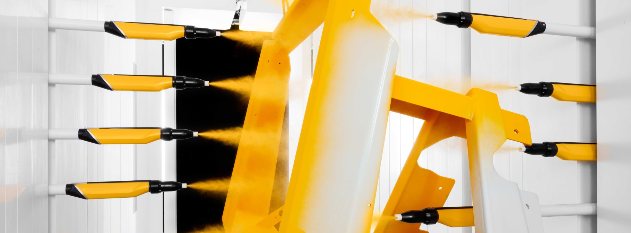
QUOTATION

VIDYARANA STEEL CORPORATION

Sirsa , Haryana

Mr. Abhinav Godara
+919355170222
abhinavgodara@gmail.com

Quotation Details
Quotation number: GIN-20-01284-OF-R0
Quotation date: 25th-July-2020

The Gema Group
Pioneer in electrostatic powder coating
Gema is a company with a long history. Founded in Switzerland in 1897 by Messrs. Gehrig and Mannhart (hence the origin of the name) Gema started as metal fabricator and later specialized in metal ceilings.
In the 1960’ years Gema started to experiment with the idea - at that time revolutionary - of electrostatic powder coating and produced the very first powder gun on the market. Although initially developed for its own use, the technology was so interesting and efficient that it was decided to start selling powder guns: the Gema electrostatic division was born!
Gema became a stand-alone company in 1982 with the spin-off of the electrostatic division.
Since 2012 Gema is part of Graco (www.graco.com), an internationally leading supplier of management solutions for fluids and coatings in both industrial and commercial applications. Part of our division are also SAT (www.sataluminium.com), market leader in vertical finishing systems for aluminum extrusions, and Hildebrand Technology (www.hildebrand-technology.com), our experts in static control solutions.
Always one step ahead
After starting first, Gema has kept its leadership position in powder coating for more than 50 years thanks to a strong focus on R&D and creativity. Over the years Gema launched so many famous innovations and unique designs, like the first gun with integrated high voltage generator, the MFR filter-belt booth, the Magic Cylinder round booth design, the SuperCorona free ions collector, the first OptiSelect manual gun with integrated remote control, the MagicCenter powder kitchen with automated color change, the EquiFlow booth airflow design, the Smart-Inline-Technology of our dense phase pumps, the contour detection laser scanner for automatic application, the new All-In-One gun control units…
Today Gema can count on the largest patents portfolio in the market and offers a broad variety of products and solutions, from manual coatings to the most sophisticated industry 4.0 automations.
A strong worldwide presence
Gema’s worldwide headquarters are in St. Gallen, Switzerland; here our team works every day to develop our newest technologies and to make sure that our products are manufactured in perfect quality and punctually delivered everywhere in the world.
Our distribution network includes a combination of Gema business units and independent distributors in more than 60 countries worldwide, offering sales and service support to maintain the Gema equipment in perfect shape for many years after the first installation.
Application experts in every market
Architectural elements, home appliances, automotive components, metallic furniture… everywhere the most famous brands rely on our expertise for their powder coating projects.
Our state-of-the-art coating laboratories are available in Europe, America and Asia for the most complex coating trials. Here our customers can test our advanced technologies and determine the most effective equipment configuration to achieve the best application quality.

Technical Description

Project Specifications

Work piece data:
Type of Object: MCB Boxes
Max Height 1000 [mm]

Production data:
Speed of Conveyor: 1.50 [m/min]

Application data:
Powder Type: Organic Powder

The design of this solution is based on the experience we have gained from several successful projects with similar technical specifications.

Technical Description

Scope of Supply

Automatic Application Equipment
1 OptiFlex AS10 electrical cabinet (Manufactured Locally)
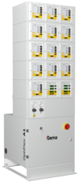
- Freestanding base cabinet, equipped with pneumatic unit, including air filter/regulator and air connection sockets for control units
- Modular upper structure designed to accommodate Gema master control , gun controls, reciprocator controls, powder hopper controls
- Power supply
Standard: 3x400 VAC+N+PE / 50/60Hz
US Market: 100-120 V 60Hz

Technical data:
Width: 600 [mm]
Depth (incl. base): 300 (550) [mm]
Max height: 1'880 [mm]
6 OptiStar 4.0 CG20 gun control
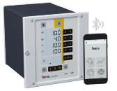
The new benchmark for gun controls
- 3 pre-set standard application programs and 250 user definable application programs - easy operation for beginners / powerful functions for the experts
- PCC technology to optimize the electrostatic charging even for challenging powders
- DVC technology grants the most precise and repeatable powder output settings
- Powder output calibration function, allowing for identical powder output at identical settings for all guns of a powder coating line, irrespective of their individual powder hose length
- Adjustment function to temporally change the powder output, without modifying the selected application program
- Wear part monitoring by working hours counters for the main wear parts
- Bluetooth connectivity to Gema E-App allowing device setup, application parameter adjustments and line data monitoring via mobile device
- Key pad lock to prevent unintended user input
- Diagnostics module and error code indication for easy trouble shooting
- Rinsing mode to remove powder accumulations from the injector, powder hose and gun

4 OptiGun GA03 automatic gun
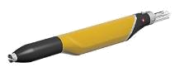
More powder on the parts - less in the recovery
- Based on Gema corona charging technology
- Integrated 100 kV high power cascade for unmatched first pass transfer efficiency
- Equipped with high efficiency nozzle, ensuring highest quality application results
- Wide selection of special nozzles available as option
- Robust design, optimized for fast & reliable color change as well as low & easy maintenance
- Designed for use of organic and metallic powders
2 OptiSelect GM04 manual gun
The manual gun for maximum coating performance
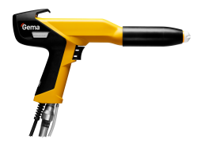
- Based on Gema corona charging technology
- Integrated 110 kV PowerBoost technology based cascade for unmatched first pass transfer efficiency
- Equipped with high efficiency nozzle, ensuring highest quality application results
- Wide selection of special nozzles available as option
- On-gun remote control to adjust all coating parameters
- Robust design, light weight and very ergonomic design
- Optimized for fast & reliable color change as well as low & easy maintenance
- Designed for use of organic and metallic powders
6 OptiFlow IG07 injector
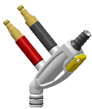
The first choice in injector technology for high performance powder conveying
- Single-component Inline Cartridge Design and 135° open angle design reduces wear consumption, guarantees a long term consistent powder flow and enables even faster wear part exchange
- Designed to work with Gema DVC Technology
- All connections equipped with quick release couplings - Plug & Convey
- Robust die-cast housing
- Designed for mounting on fluidized powder hopper, includes suction tube
1 HF100 powder hopper (Manufactured Locally)
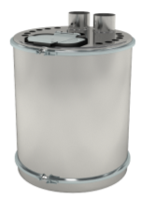
- High quality fluidized bed, designed to accommodate up to 12 injectors
- Opening for automatic powder supply and opening with lid for manual powder supply and inspection
- Easy to clean stainless steel construction
- Opening to accommodate level probe
- Air mover

Technical data:
Diameter 24 mm
Height 600 mm
Capacity 100 l
1 Caster for HF powder hoppers

1 OptiAir CA12 powder hopper control
Ideal for optimal powder conditioning
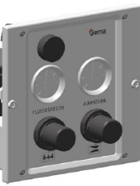
- Manual pressure regulators and pressure gauges for fluidizing and air mover
- Manual pre- fluidizing function to "loosen up" compacted powder

Reciprocators and Automation Equipment
2 OptiMove CR08 reciprocator control unit
The most powerful and user-friendly reciprocator control
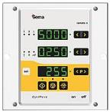
- control unit for one Gema ZA reciprocator or XT axis
- Clear interface for an intuitive operation
- Stores and recalls reciprocator programs for an easier automated operation of the line. More reproducible coating results!
- Different operating modes to meet every need:
- oscillating mode, with up to 250 programs; each program consists of lower reverse point, upper reverse point and speed
- positioning mode, with up to 250 programs; each program consists of end position and speed. Typical for horizontal XT axis
- sequential mode, with up to 250 program steps; realize complex movement cycles, consisting of individual segments with different end positions and speeds
- Installation in the OptiFlex AS cabinet

Technical data:
Positioning error < 5 [mm]

2 ZA10-18 Reciprocator
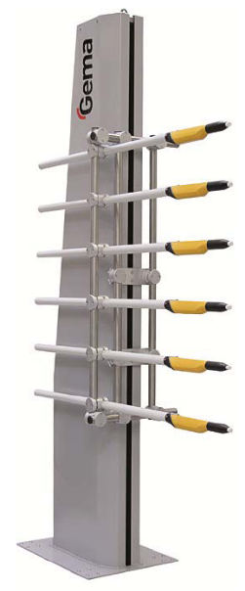
The easy solution for your automation needs
- Reliable trouble-free operation with minimum maintenance costs
- Smooth acceleration, ideal for the best coating results
- Vertical carriage with plastic rollers and belt drive
- Synchronous motor

Technical data:
Height 2760 [mm]
Width (base) 550 [mm]
Width (column) 250 [mm]
Depth 750 [mm]
Stroke 1800 [mm]
Speed 0.08 to 0.6 [m/s]
Acceleration 0.1 – 2.0 [m/s²]
Max load 25 [kg]
Power consumption 0.4 [kVA]
Max cable length to the CR control 20 [m]
2 Trolley for manual displacement of one reciprocator
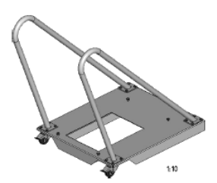
- Base trolley
- Rollers and locking clamps
- Handles to move the reciprocator
4 Gun supports

Installation and Training
Start-up and training with a specialized Gema engineer

Comercial Offer

1.Gema Automatic Guns-4 Nos
2.Gema Reciprocators-2 Nos
3.Gema Manual Gun-2 Nos
4.Cabinet for contollers- 1 Nos
5.SS Hopper(100 Ltr)- 1 Nos.

Total Price(1to5)-Rs.3000000(Rupees Thirty Lakh Only)

COMMERCIAL TERMS AND CONDITIONS

- The price quoted is ex-works Greater Noida.

- GST@18% will charge extra

Freight and Insurance will be at actuals to your account.

- Payment Terms:

* 50% of basic order value as advance along with technically &
Commercially clear purchase order.
* 50% along with full taxes against Performa Invoice prior to dispatch on pro data basis.

4. Delivery will be within 30 Days from the date of receipt of your commercially and technically clear Purchase Order along with 50% advance.

5.Warranty: the equipments offered by us are warranty for 12
Calendar months from the date of dispatch against any manufacturing defects.

6. Validity: our offer is valid only for 30 days from the date of this offer.

For Value Added Coating Solution Pvt. Ltd.

Harish Sharma
(Director)

